Projects Details

In the home page there will be a launch challenge button in which any person (visitor) can fill the details. The form will contain the fields – Individual/Company name, Email, Phone, Contact Person Number.

In the other solve challenge button the user will be redirected to the login/register page.

The login/ register page will contain the header and footer. It will be somewhat like this:-

<https://www.innocentive.com/ar/login/index>

**The sign Up page details :-** Name,Email,Phone number ,Address,

Area of Expertise:- Other , Electricity , Workforce Management,Logistics, technology, Process and Quality

Type- Individual , Group , Company , other

The Challenge UI - 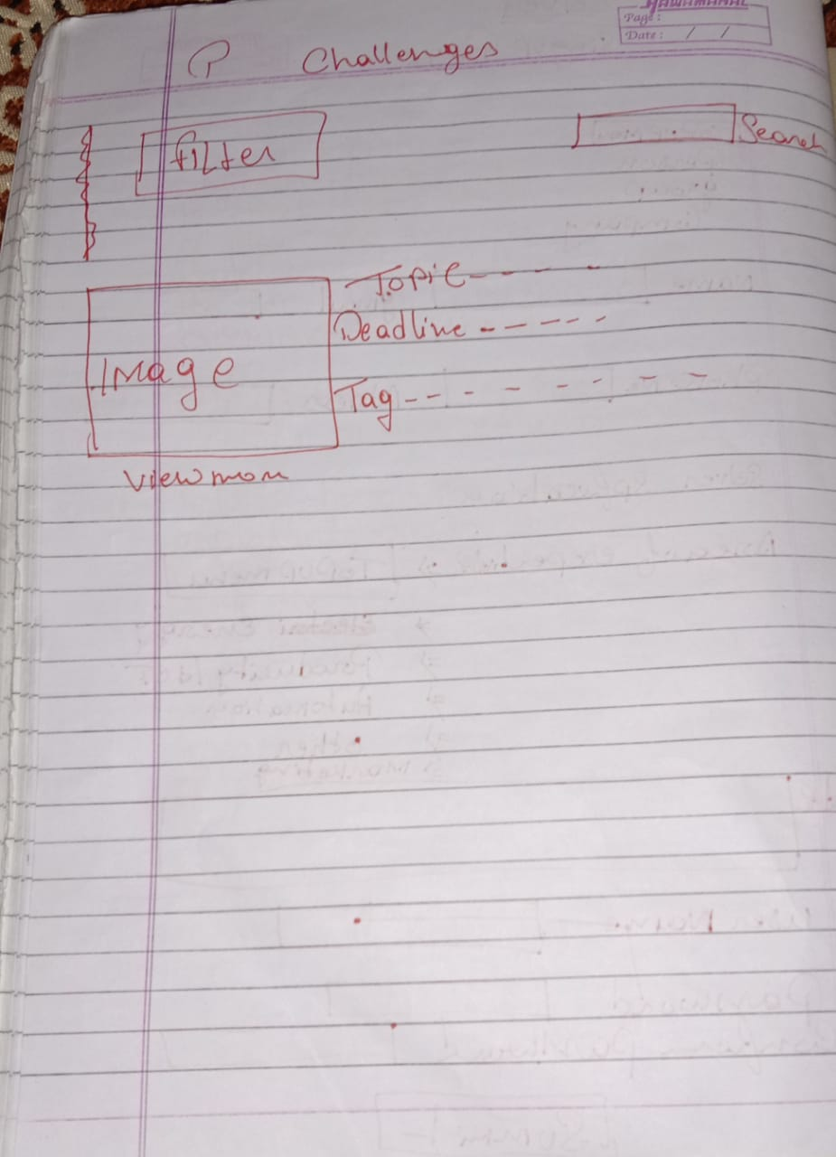

When clicking on a particular challenge , details that will be shown are:- Heading wise – Problem statement , Summary, Requirement, images/video . Somewhat like this:- <https://www.innocentive.com/ar/challenge/9934293> .

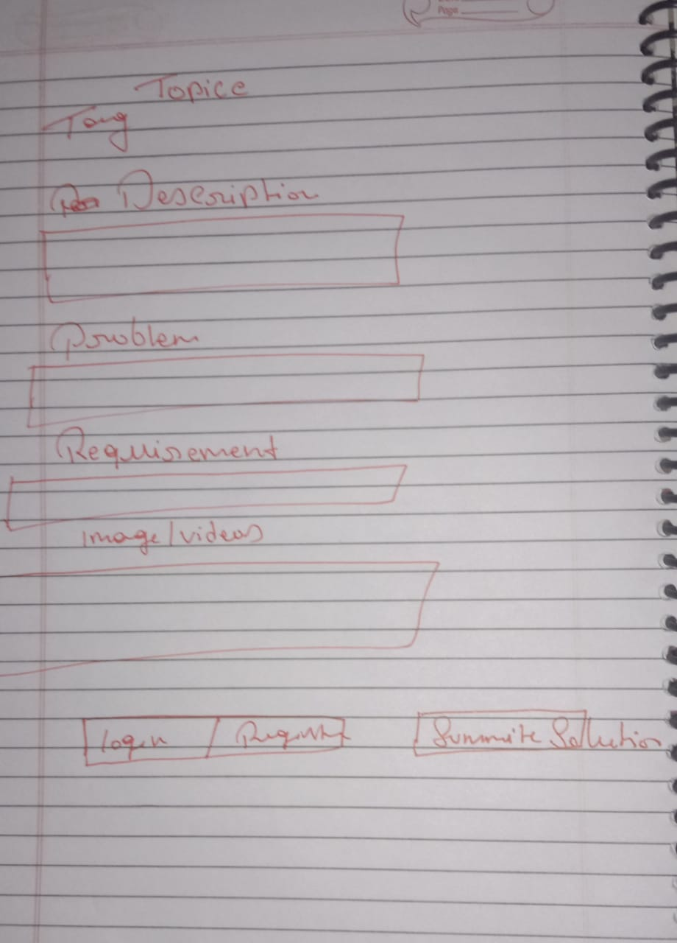

To solve the challenge the user has to log in .

**Admin Panel**

User1 will be an employee of the client. All the details of the launch button form will be sent to him. (By email)

He will contact them and then write all the details in the admin panel. The details will be Problem Topic, Tag ( eg- IOT, Health) , Summary(text), Problem Statement(text), Requirement(text), Image/Video(multiple possible)

The details will be sent to the admin. He will approve them or if does not approve, he will write a comment (telling which part is missing). After he approves of them, the challenges will be sent to the main challenge dashboard where anybody can see them.

In the **admin panel** there will be a table containing the list of registered users and their details along with the deactivate button which will delete the user from the table and send the data to the deactivated users list in the backend database.

The table contain Name, Phone, and Email of the user and in the side there will be a button “view more details”. On clicking it the admin can see all the details of the user.

In home page, in the bottom right add a button like this link. This popup on clicking “Email Us” . Start from Please leave a message below part and till the end. The fields will – Name , Business Email ,Question

